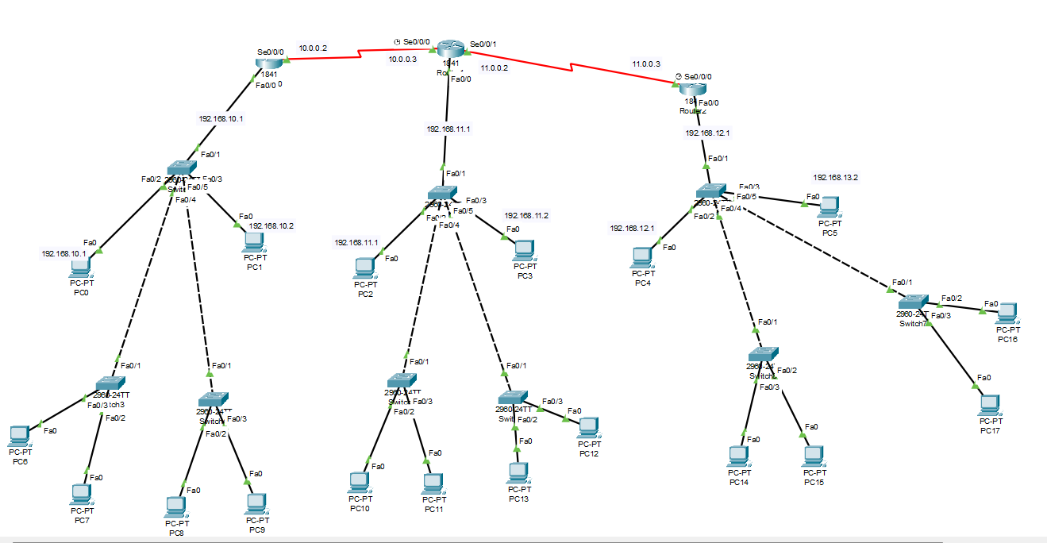Q1.

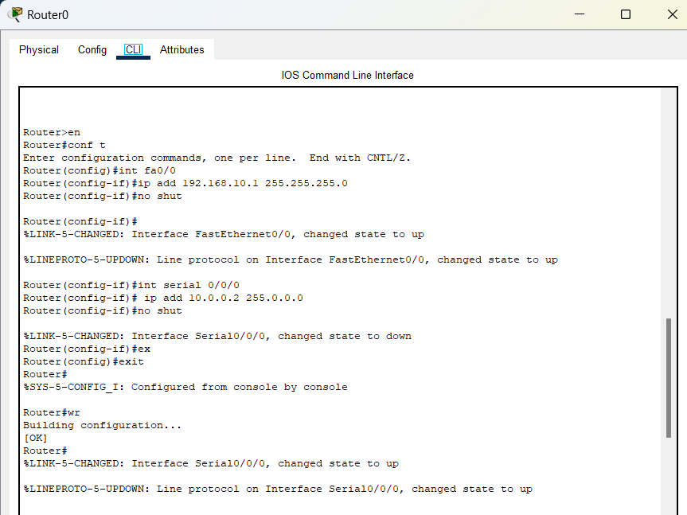

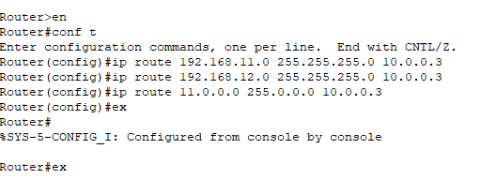

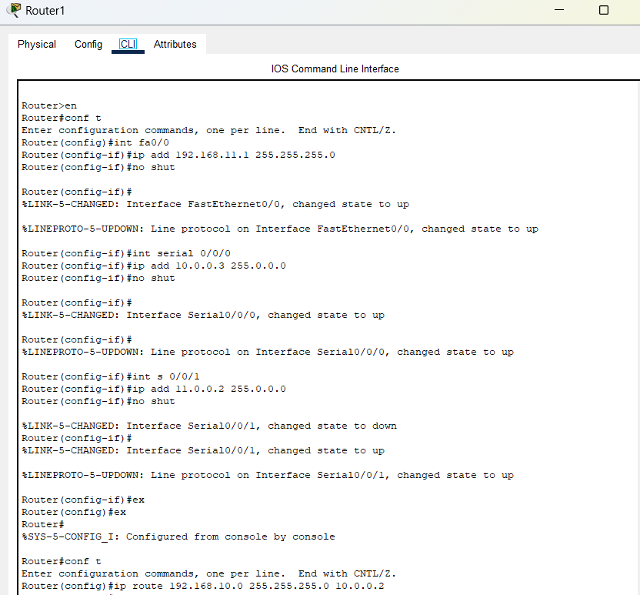

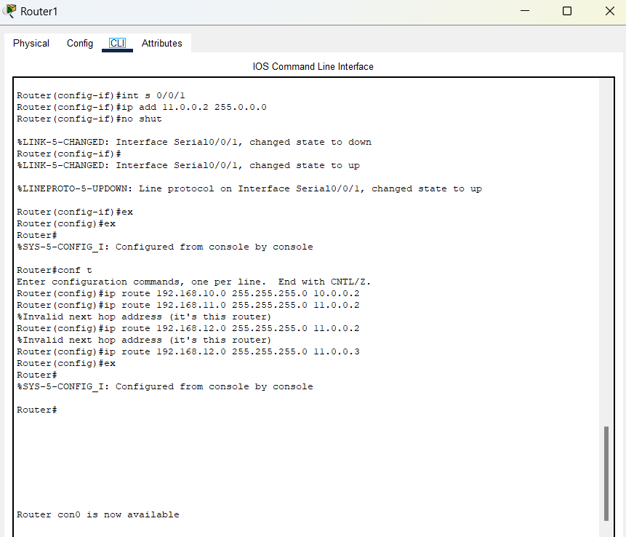

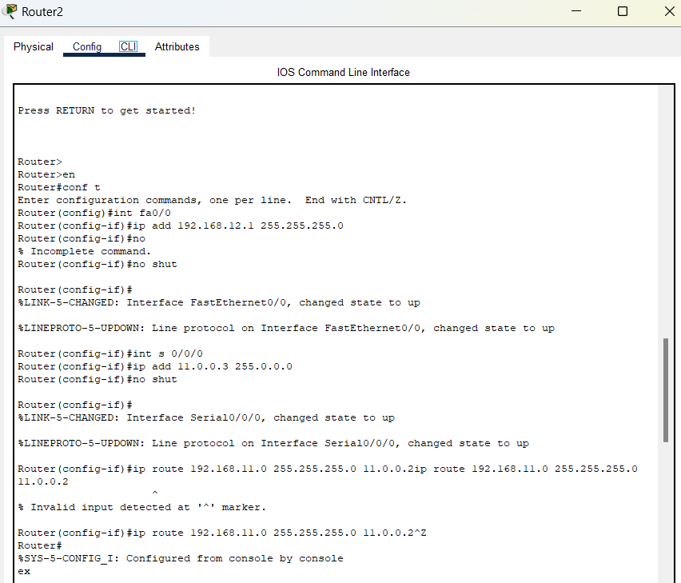

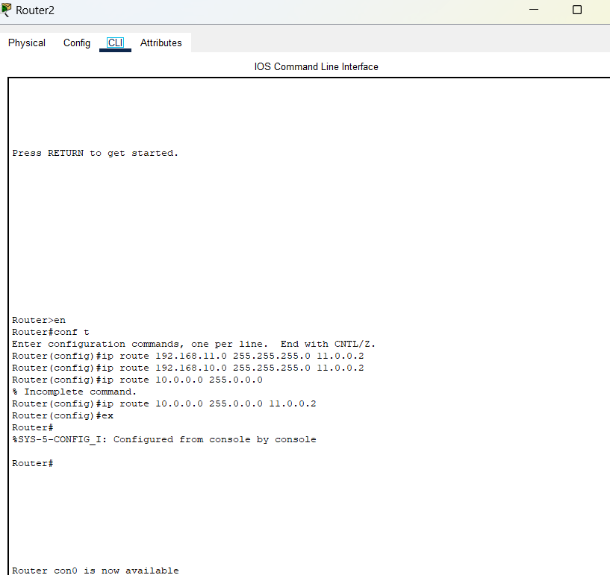

Router 1…

Router>en

Router#conf t

Enter configuration commands, one per line. End with CNTL/Z.

Router(config)#int fa0/0

Router(config-if)#ip add 192.168.10.1 255.255.255.0

Router(config-if)#no shut

Router(config-if)#

%LINK-5-CHANGED: Interface FastEthernet0/0, changed state to up

%LINEPROTO-5-UPDOWN: Line protocol on Interface FastEthernet0/0, changed state to up

Router(config-if)#int serial 0/0/0

Router(config-if)# ip add 10.0.0.2 255.0.0.0

Router(config-if)#no shut

%LINK-5-CHANGED: Interface Serial0/0/0, changed state to down

Router(config-if)#ex

Router(config)#exit

Router#

%SYS-5-CONFIG_I: Configured from console by console

Router#wr

Building configuration...

[OK]

Router#

%LINK-5-CHANGED: Interface Serial0/0/0, changed state to up

%LINEPROTO-5-UPDOWN: Line protocol on Interface Serial0/0/0, changed state to up

Router>en

Router#conf t

Enter configuration commands, one per line. End with CNTL/Z.

Router(config)#ip route 192.168.11.0 255.255.255.0 10.0.0.3

Router(config)#ip route 192.168.12.0 255.255.255.0 10.0.0.3

Router(config)#ip route 11.0.0.0 255.0.0.0 10.0.0.3

Router(config)#ex

Router#

%SYS-5-CONFIG_I: Configured from console by console

Router#ex

Routers: 2

|  |
| --- |
| Router>en  Router#conf t  Enter configuration commands, one per line. End with CNTL/Z.  Router(config)#int fa0/0  Router(config-if)#ip add 192.168.11.1 255.255.255.0  Router(config-if)#no shut  Router(config-if)#  %LINK-5-CHANGED: Interface FastEthernet0/0, changed state to up  %LINEPROTO-5-UPDOWN: Line protocol on Interface FastEthernet0/0, changed state to up  Router(config-if)#int serial 0/0/0  Router(config-if)#ip add 10.0.0.3 255.0.0.0  Router(config-if)#no shut  Router(config-if)#  %LINK-5-CHANGED: Interface Serial0/0/0, changed state to up  Router(config-if)#  %LINEPROTO-5-UPDOWN: Line protocol on Interface Serial0/0/0, changed state to up  Router(config-if)#int s 0/0/1  Router(config-if)#ip add 11.0.0.2 255.0.0.0  Router(config-if)#no shut  %LINK-5-CHANGED: Interface Serial0/0/1, changed state to down  Router(config-if)#  %LINK-5-CHANGED: Interface Serial0/0/1, changed state to up  %LINEPROTO-5-UPDOWN: Line protocol on Interface Serial0/0/1, changed state to up  Router(config-if)#ex  Router(config)#ex  Router#  %SYS-5-CONFIG_I: Configured from console by console  Router#conf t  Enter configuration commands, one per line. End with CNTL/Z.  Router(config)#ip route 192.168.10.0 255.255.255.0 10.0.0.2  Router(config)#ip route 192.168.11.0 255.255.255.0 11.0.0.2  %Invalid next hop address (it's this router)  Router(config)#ip route 192.168.12.0 255.255.255.0 11.0.0.2  %Invalid next hop address (it's this router)  Router(config)#ip route 192.168.12.0 255.255.255.0 11.0.0.3  Router(config)#ex |

**Router 3…**

|  |
| --- |
| Router>  Router>en  Router#conf t  Enter configuration commands, one per line. End with CNTL/Z.  Router(config)#int fa0/0  Router(config-if)#ip add 192.168.12.1 255.255.255.0  Router(config-if)#no  % Incomplete command.  Router(config-if)#no shut  Router(config-if)#  %LINK-5-CHANGED: Interface FastEthernet0/0, changed state to up  %LINEPROTO-5-UPDOWN: Line protocol on Interface FastEthernet0/0, changed state to up  Router(config-if)#int s 0/0/0  Router(config-if)#ip add 11.0.0.3 255.0.0.0  Router(config-if)#no shut  Router(config-if)#  %LINK-5-CHANGED: Interface Serial0/0/0, changed state to up  %LINEPROTO-5-UPDOWN: Line protocol on Interface Serial0/0/0, changed state to up  Router(config-if)#ip route 192.168.11.0 255.255.255.0 11.0.0.2ip route 192.168.11.0 255.255.255.0 11.0.0.2  ^  % Invalid input detected at '^' marker.  Router(config-if)#ip route 192.168.11.0 255.255.255.0 11.0.0.2^Z  Router#  %SYS-5-CONFIG_I: Configured from console by console  ex  Router>en  Router#conf t  Enter configuration commands, one per line. End with CNTL/Z.  Router(config)#ip route 192.168.11.0 255.255.255.0 11.0.0.2  Router(config)#ip route 192.168.10.0 255.255.255.0 11.0.0.2  Router(config)#ip route 10.0.0.0 255.0.0.0  % Incomplete command.  Router(config)#ip route 10.0.0.0 255.0.0.0 11.0.0.2  Router(config)#ex  Router#  %SYS-5-CONFIG_I: Configured from console by console |